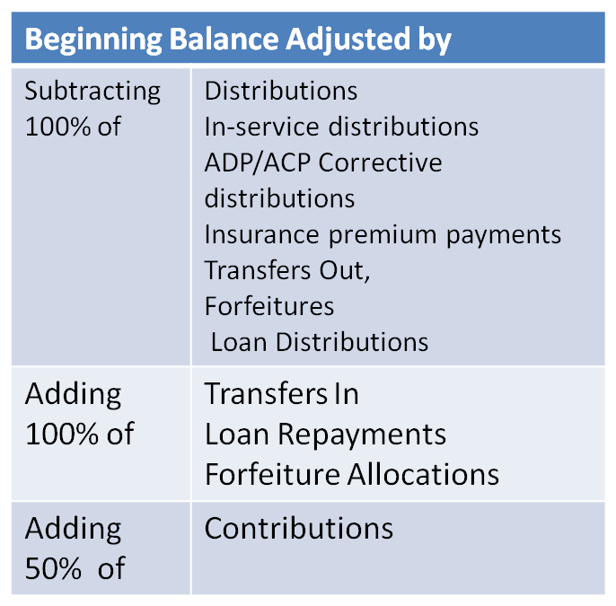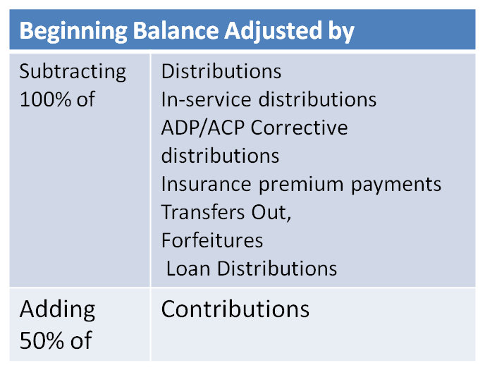
Earnings Allocation - Basis Methods
All Transactions
All Transactions
19
Current Year Factor =100%; Current Year Contribution Factor= 50%
Traditional
Retirement & Benefits Compliance Customer Conference

